# CS 255 System Design Document Template

## UML Diagrams

### UML Use Case Diagram

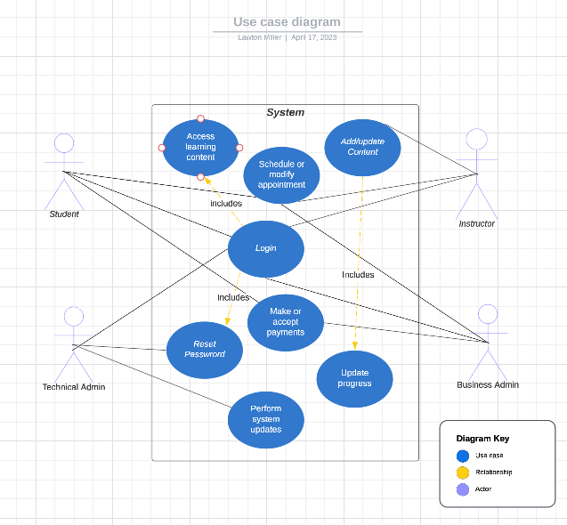

### UML Activity Diagrams

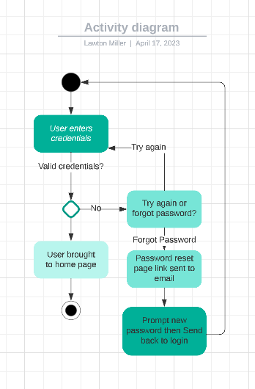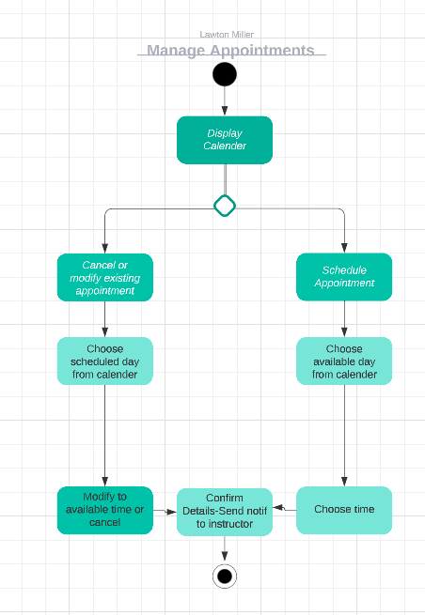

### UML Sequence Diagram

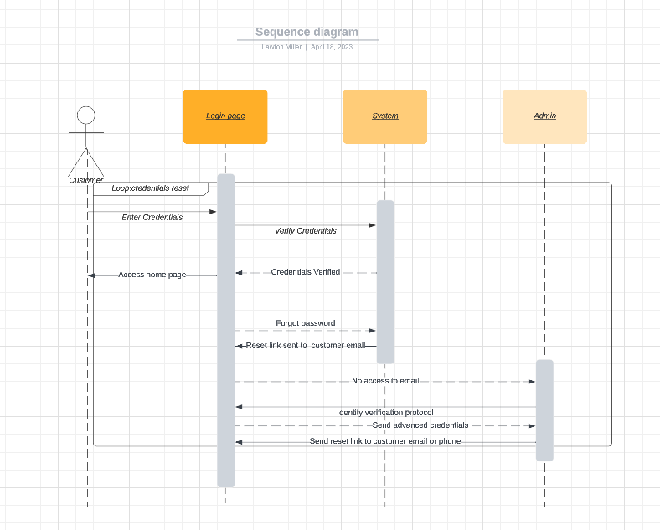

### UML Class Diagram

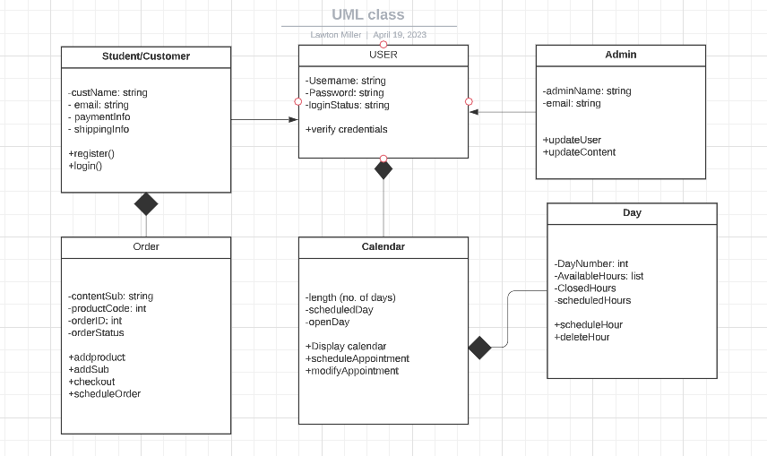

## Technical Requirements

The system will need specific technical specifications. It should run on web-based environments, be managed on a cloud-based server, and offer offline study. It should provide a search function, grading system, and generate notifications for appointments and curriculum changes. It should have a discussion board and private messaging system, and user credentials should be case sensitive. Different user types should have different permissions for access, and the platform should log and report slowdowns. All admin users should be able to add or remove other users without code changes.